Airlines Analysis

A) Find list of Airports operating in the Country India

create table india_opert_airport as select * from airports where airport_country LIKE '%India%';

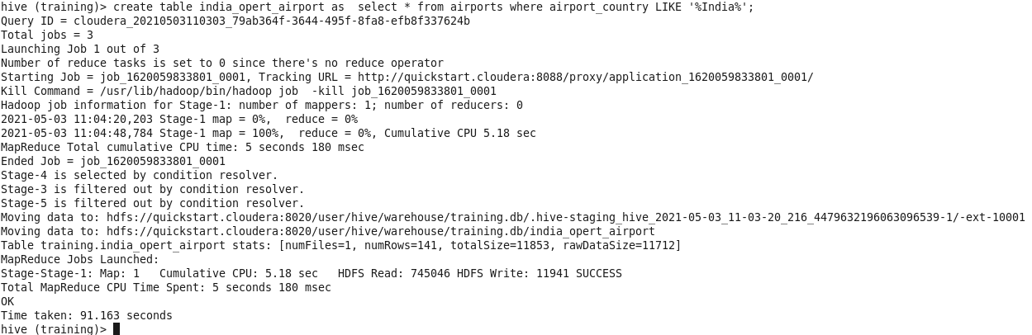

select * from india_opert_airport limit 10;

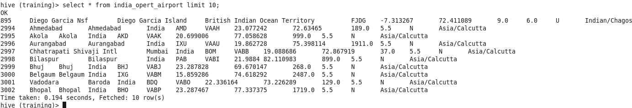

B)Find the list of Airlines having zero stops

create table stop as select * from routes where route_stops LIKE '%0';

select * from stop limit 10;

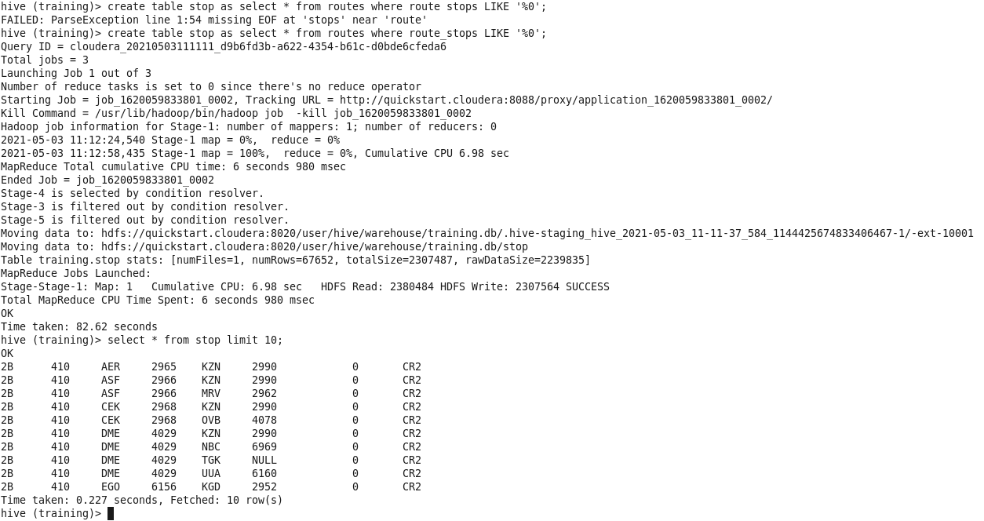

C) List of Airlines operating with code share

create table codeshare_1 as select * from routes where routes_codeshare LIKE '%Y%';

select * from codeshare_1 limit 10;

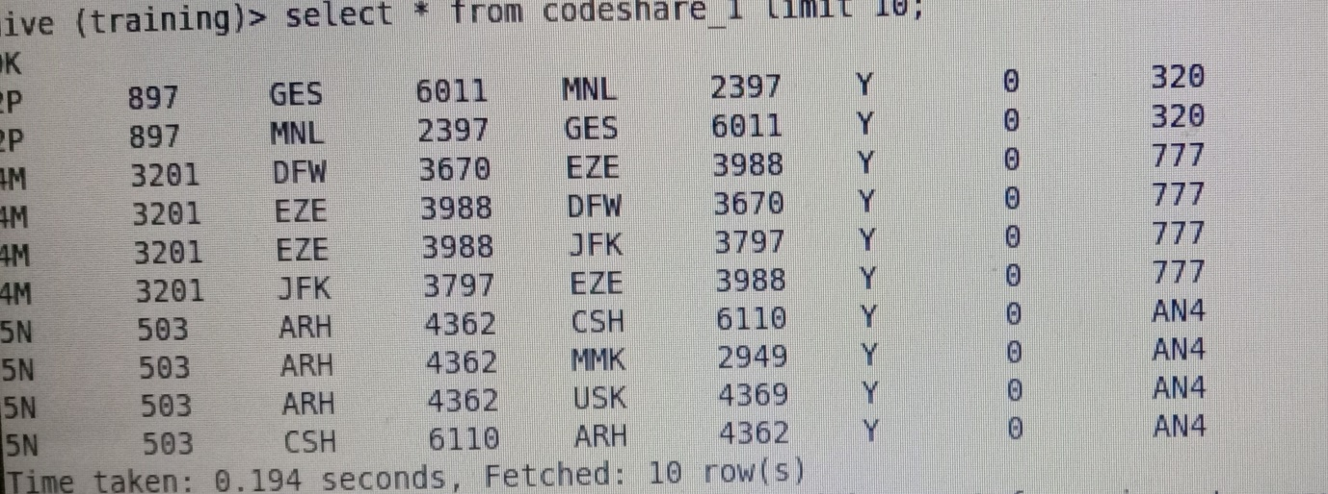

D) Which country (or) territory having highest Airports

select airport_country,count(*) as cnt from airports group by airport_country ORDER BY cnt DESC;

